Unique operation for outstanding performance and value
There are three major system components, which make up Integrated Security’s patented Hydra system: Mesh Based Wireless Intelligent Sensors, a Gateway, and Alarm Relay Modules. The modular components of the Hydra system allow it to scale depending on the application and coverage requirements. Smaller sites use one Gateway while larger sites can be covered using remote interconnected Gateways.
SENSING TECHNOLOGIES
Hydra employs a network of sensors to detect intruders using two independent sensing technologies to confirm intrusion activity. Information is passed on to the Hydra Gateway and then to Alarm Relay Modules, which can be connected to an alarm panel, an integrated intrusion detection system, or its own independent interface. The modular components of the Hydra system allow it to scale depending on the application and coverage requirements.
Hydra Processor
The Hydra Processor is a compact, cost effective yet robust set of electronics which houses the Gateways, Alarm Relays and associated power sourcing / protection equipment.
A closer look inside the Hydra Processor illustrates the key components: 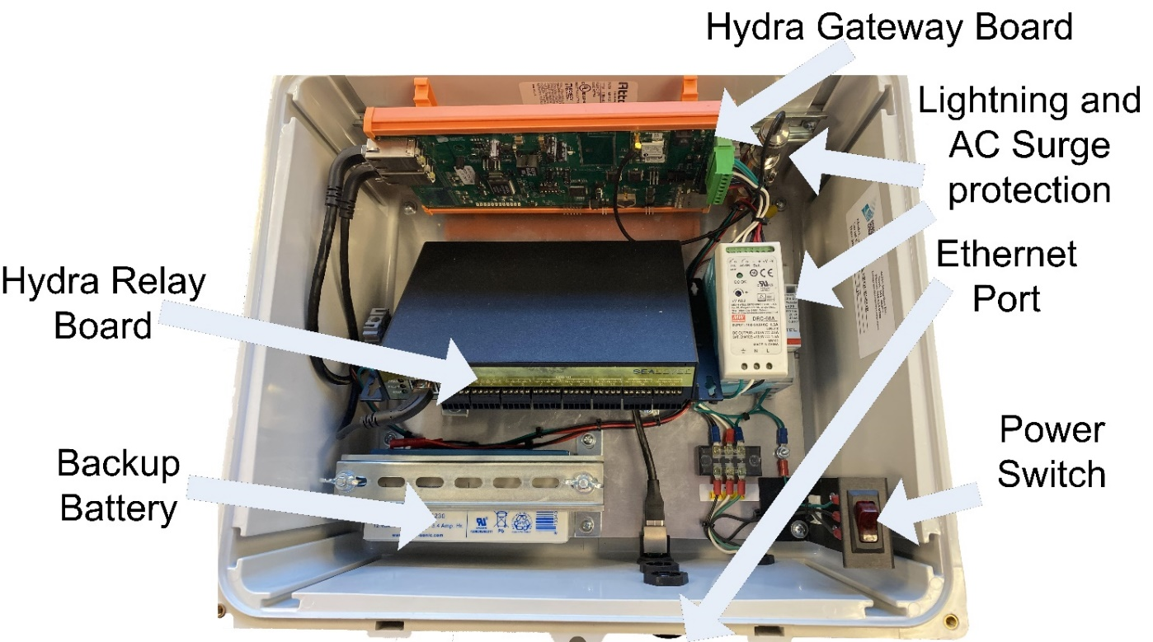

Getting started
The Hydra Mesh is self-forming meaning the sensors automatically form redundant wireless links to both the Gateway board and other sensors. We will start with the Hydra Site Design Layout to understand the key components and their locations:
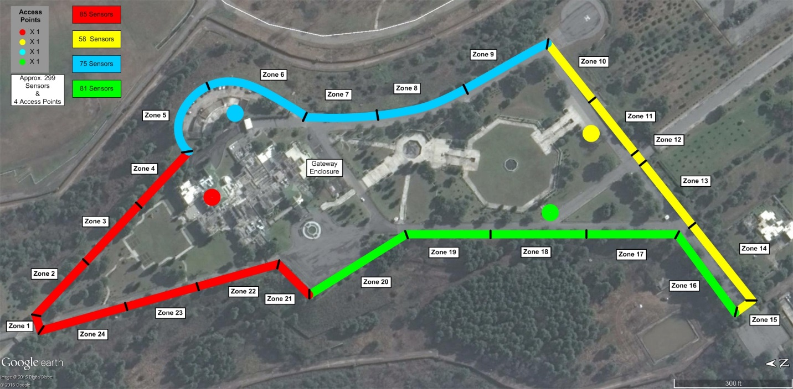
This site plan locates the antennas, zones, processor, and access point along with defining the zoning and which zones belong to which Gateway board.
When planning the mesh, a few things should be kept in mind for best results:
- Each sensor should have no fewer than 3 good neighbors (shown in webpage)
- 3 hops or less is ideal, meaning the path back to the gateway relies on 2 or fewer other sensors/access points. Maximum of 8 hops to maintain 99.999% reliability
- When an access point is required, try to use an access point for each 20 relayed sensors
- The Latency figure in the network status page of the Gateway Board is a good metric to determine communication strength. More latency = more retried or more hops required. Getting this number below 5000 for a full network is a great target

Hydra Overall Installation Process:
The Hydra system was designed for reliable, efficient, and flexible performance and installation. A general overview of the installation process can be summarized as follows:
- Using the site layout plan identify the locations of the Gateway antennas, Gateway’s sensors, and processor location. The antenna needs to be connected by a maximum 50 foot antenna cable, so consider placement of the Gateway Antenna, you must also consider the distance and path to the Gateway Board.
- Install the processor and provide appropriate line voltage. Do not power the processor at this time.
- Install the antenna with the provided bracket and mast for each Gateway. Ensure the antenna is mounted in an elevated position (above the roofline) with the best possible view of its sensors minimizing any obstructions. When using multiple antennas, they should be no closer than 10 feet apart. Ensure the antenna is vertical and all connections and coax clearance holes are sealed and watertight.
- The coax assembly is made up of a coax length from antenna to a bulkhead in the Hydra enclosure. Inside lies a surge suppressor and a pigtail that connects the Hydra Gateway board. Install and route the coax cable from antenna to Hydra enclosure. Be sure to maintain a minimum of a 6” bend radius of as the coax cable is routed.
- Switch on power to the Processor using the rocker switch.
- Install and power any Access Points using the site plan.
- Ensure the Access Point joins the network.
- Install and power all sensors, working zone by zone and documenting as you go.
- Ensure all sensors in that zone:
  - Are in the Reporting State – DO NOT move to the next step unless the sensor is Reporting
  - Have been assigned a Zone
  - Have been sent the appropriate Zone Setup
- Secure the cover for each sensor in that zone with all 4 screws using ISC torque limiter.
- Repeat steps 8 – 10 for the next zone.
- Test each sensor to ensure proper operation.
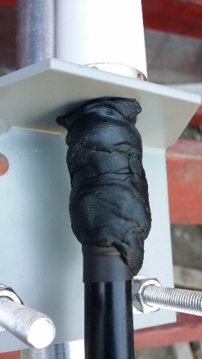
Detailed Installation Instructions
Antenna, Lightning Suppressor, and Antenna Cable Installation:
- First locate and install the antennas using the mast, brackets, and antenna assembly. Ensure the N coax cable to antenna connection is properly sealed using the provided sealant with the antenna, see figure 1

Figure 1
- The final assembly should look as shown in figure 2

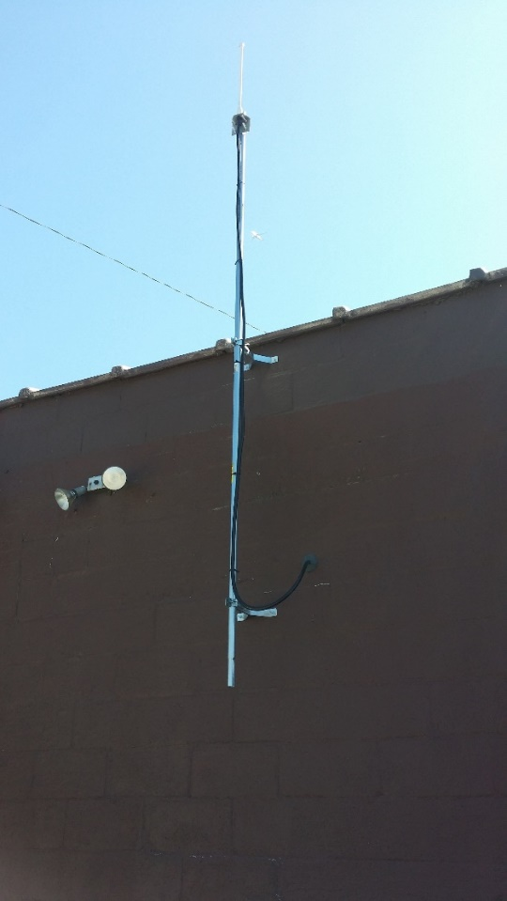
- Route the Coax Assembly and secure connections from the antenna to the bulkhead on the Hydra Processor

NOTES:
- Maximum total length of the entire coax assembly should not exceed 50 feet in length.
- Maintain a 6” bend radius on the Antenna Cable on installation runs

Figure 2

Processor:
- Connect desired alarm relay outputs to your system interface using up to 27 zone alarm relay outputs. Note these are Form C contacts where every 2 relays has the commons tied together.
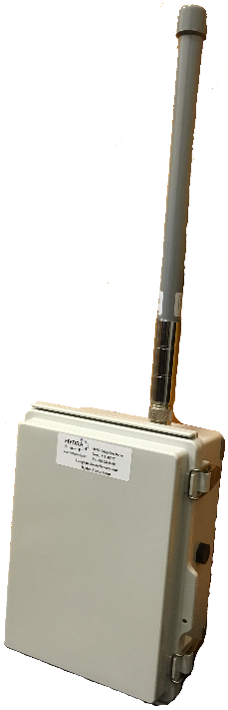
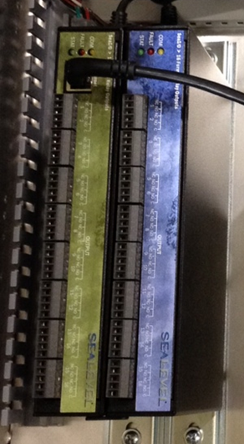

Access Point Installation:
- Mount the access point with the pole mount bracket and clamps provided.
- Try to keep the access point elevation at the same elevation as its Gateway Antenna.
- Power the Access Point by turning the sensor’s power switch on
- Monitor the Gateway’s Web Page (see Hydra Guide for details on how to view) and ensure the Access Point joins the network and becomes reporting (this device is not assigned a zone.)

Sensor Installation:
- Before going into the field first install only SAFT L17500 A size batteries in the Hydra Sensor ensuring the correct polarity
- Loosely, secure the sensor on the fence using 2 nylon zip ties or 2 stainless steel ties, approximately 1 foot right of the pole on a flat surface pattern. This ensures that the enclosure base is unstrained or twisted by any fence conditions before the cover is secured. The cover will be held in place temporarily with the rubber band.
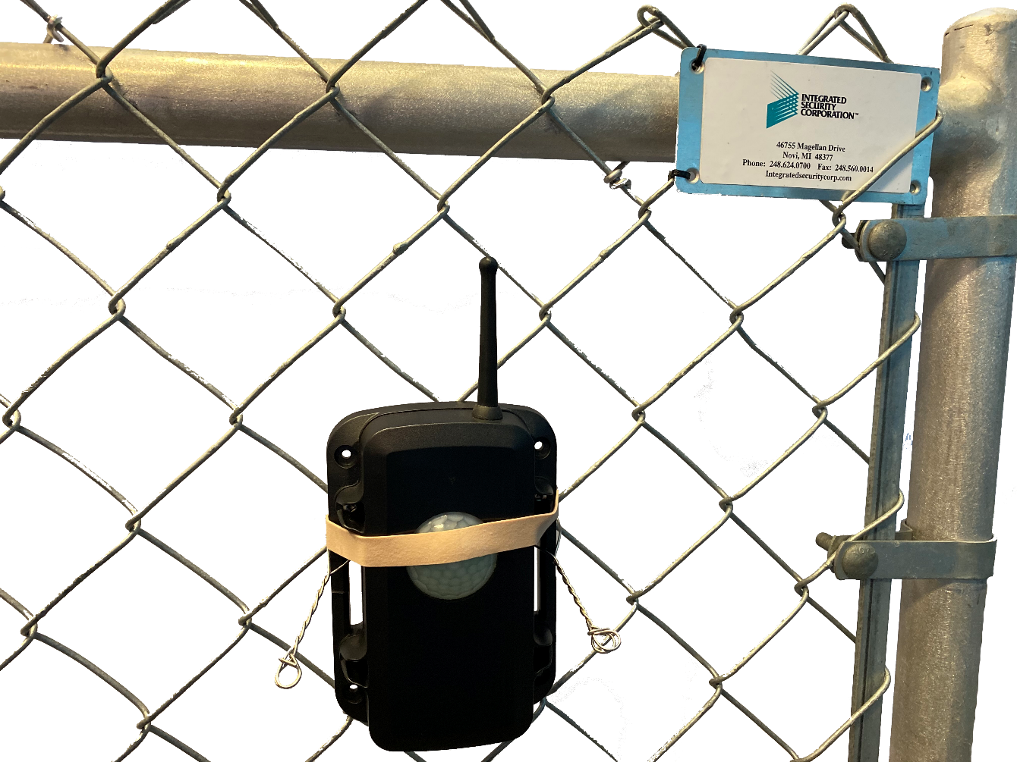

- Using the Torque Limiter and provided screws, secure the cover to the case. Once all four screws are properly torqued, pull the zip ties tight to secure it to the fence.

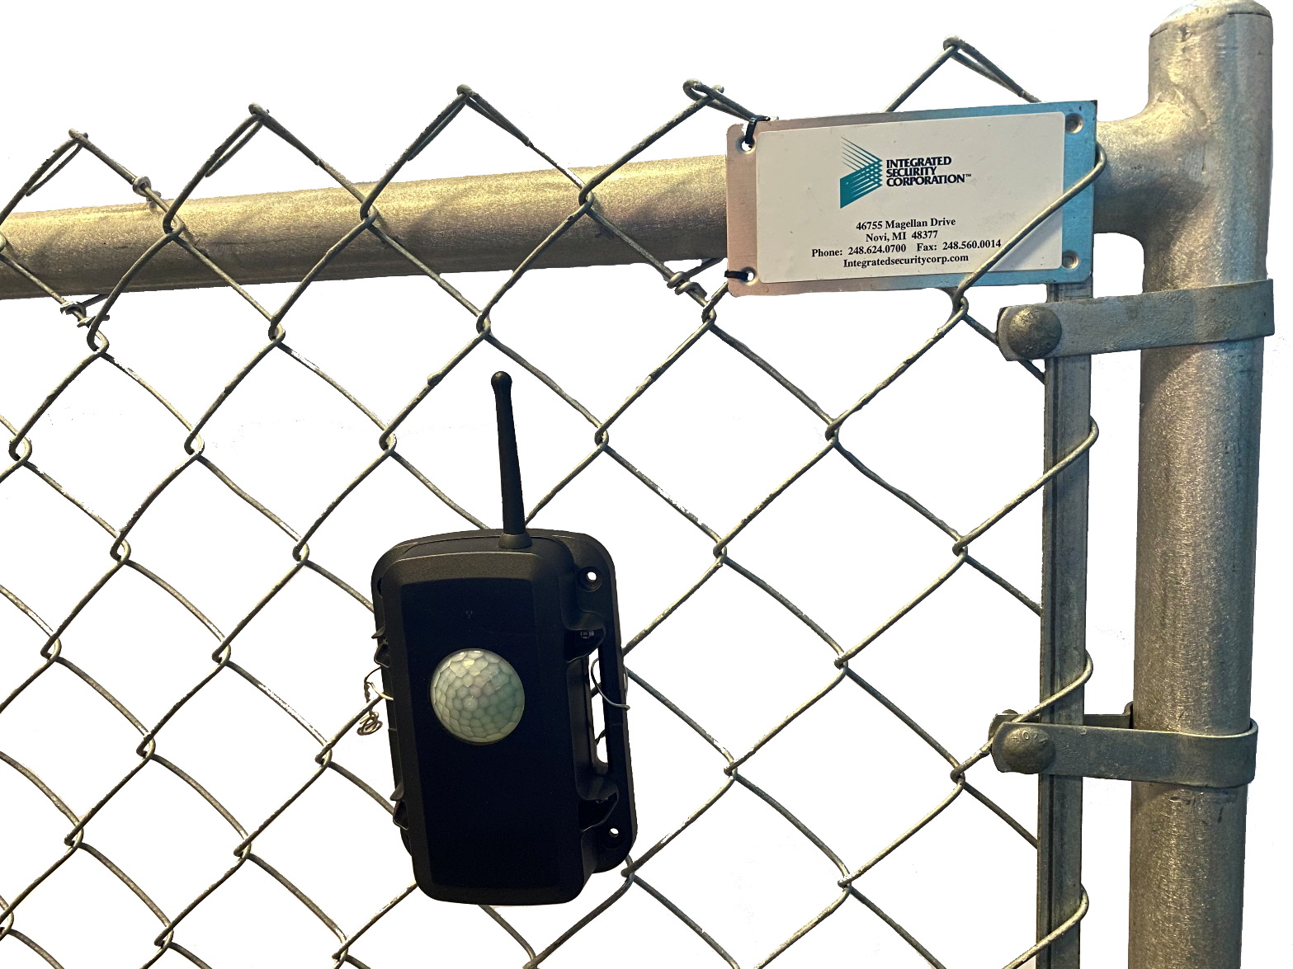
- Install the sensors one zone at time. (Note that the sensor is not waterproof if the screws are not installed properly, plan installation accordingly)

NOTES:
- Mount the sensors 1 foot from the vertical fence poles approximately 5 feet high on a 6-foot fence or 6 feet high on fences taller than 6 feet.
- While using the Torque Limiter, make sure the drill is set to the highest torque setting. This will prevent the torque setting on the drill from limiting torque rather than the torque limiter itself.

Sensor Network Setup:
- Ensure the processor has been powered
- NOTE: INSTALL AND MOUNT only one zone at a time as the wireless mesh network is self-forming and the user will not know which sensors are located where for zone assignment
- For each mounted sensor in that zone, turn on the switch in the lower left
- Access the Gateway’s web page and monitor the Sensor Network Status page to ensure the sensors are in the REPORTING state which indicates the sensor can accept configuration commands and report alarm activity.
- Once in the Reporting state enter the Zone Assignment page and assign a Zone to that sensor via the pull-down menu
- Set sensor sensitivity and other parameters using the Zone Setup page
- Secure the cover for each sensor in that zone with all 4 screws using ISC torque limiter.
- Repeat steps 3 – 7 for the next zone.
- Test each sensor to ensure proper operation.
- Refer the Hydra Guide for more details

- Make sure the Gateway’s #2 DIP SWITCH is in the correct position for which relay you want to map the System Alerts to. ON is the 1st relay and OFF is the 2nd.
- The Gateway’s Antennas must have at least 10 feet separation between them.
- With the Torque Limiter attached to a drill, make sure the drill is set to the highest power (drill) in order to cause the Torque Limiter to break-over (> 8 in-lbs.) before the drills clutch does.

